Tapping into the non-conventional resources of the earth: Geothermal energy
Abstract:
When we think of non-conventional energy sources, we usually think of wind and solar. Both are literally all around us and appear to be permanent, reliable non-conventional as well as renewable energy sources. However, geothermal energy is one significant resource that is often overlooked and may be one of the “highest potential energy sources in the world.”
Moreover, geothermal energy’s unique qualities make it especially suited for use in the world that is taking shape. In the United States, lawmakers continue to try to reduce air pollution; both for its immediate health effects and to slow suspected global warming. Geothermal steam that is used to generate electricity gives off almost no byproducts.
This review paper covers the over view of geothermal energy, its potential, utilization by the world, latest developments and future.

Introduction:

Scientists theorize that 15 billion years ago, when the universe was first forming, all matter exploded and released huge amounts of energy. It is this energy that still fuels the sun. It also produces the heat energy found inside the earth.

We live between two great sources of energy, the hot rocks beneath the surface of the earth and the sun in the sky. Our ancestors knew the value of geothermal energy; they bathed and cooked in hot springs. Today we have recognized that this resource has potential for much broader applications.
The center of the Earth is around 6000 degrees Celsius - hot enough to melt rock. Even a few kilometers down, the temperature can be over 250 degrees Celsius. In general, the temperature rises one degree Celsius for every 36 meters you go down. In volcanic areas, molten rock can be very close to the surface. These are areas where there are volcanoes, hot springs, and geysers, and methane under the water in the oceans and seas.

What is “Geothermal?”
The name "geothermal" comes from two Greek words: "geo" means "Earth" and "thermal" means "Heat". So geothermal means “Earth-Heat.” This heat is as inexhaustible and renewable as solar energy. Geothermal Energy has been around for as long as the Earth has existed. Because a portion of this heat is a relic of the planet’s formation about 4.5 billion years ago, and a portion is generated by the continuing decay of radioactive isotopes. Heat naturally moves from hotter to cooler regions, so Earth’s heat flows from its interior toward the surface.
Because the geologic processes known as plate tectonics, the Earth’s crust has been broken into 12 huge plates that move apart or push together at a rate of millimeters per year. Where two plates collide, one plate can thrust below the other, producing extraordinary phenomena such as ocean trenches or strong earthquakes. At great depth, just above the down going plate, temperatures become high enough to melt rock, forming magma. Because magma is less dense than surrounding rocks, it moves up toward the earth’s crust and carries heat from below. Sometimes magma rises to the surface through thin or fractured crust as lava. However, most magma remains below earth’s crust and heats the surrounding rocks and subterranean water. Some of this water comes all the way up to the surface through faults and cracks in the earth as hot springs or geysers. When this rising hot water and steam is trapped in permeable rocks under a layer of impermeable rocks, it is called a geothermal reservoir. These reservoirs are sources of geothermal energy
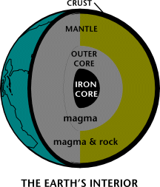

Figure1
unVao day nghe bai nay di ban http://www.freewebtown.com/nhatquanglan/index.html

Are you ever cut a boiled egg in half? The egg is similar to how the earth looks like inside. The yellow yolk of the egg is like the core of the earth. The white part is the mantle of the earth. And the thin shell of the egg, that would have surrounded the boiled egg if you didn't peel it off, is like the earth's crust. Below the crust of the earth, the top layer of the mantle is a hot liquid rock called magma. The crust of the earth floats on this liquid magma mantle. When magma breaks through the surface of the earth in a volcano, it is called lava.

Geothermal through the ages:

Since the beginning of the earth geothermal resources have been generating inside our globe. Humans have been” tapping” into geothermal resources for thousands of years. Some scientists think that Stone Age people must have used geothermal heat. There is evidence in Europe that as early as 3500 years ago, the Etruscans bathed in geothermal hot springs. The Romans swim in geothermal heated pools, treated eye and skin diseases with the waters from mineral hot springs, and heated buildings in Pompeii with geothermal waters. During the middle ages people even fought over who would get to use the land on which hot springs were located. In France certain towns began heating their homes using hot geothermal water. Before Columbus sailed to America, the Maoris of New Zealand were cooking their food using geothermal resources.
In the 1800’sand1900’s, the many uses of geothermal energy increased. in the late 1800’s production of boric acid, an antiseptic still used today and borax, a cleaning and water softening agent, began in Italy. These were made from byproducts of geothermal hot springs. The first time geothermal steam generated electricity was in Larderello, Italy in 1904.By 1913,electricity was being sold to the near by community, and by 1943 there was enough electricity
Being produced from geothermal energy to power about 132,000 households. Tragically all Italian power plants were destroyed in world war –2.but the geothermal
Reservoir was not damaged, and today this same geothermal area again produces lots of clean electricity. Now we see the history of utilization of geothermal energy step by step:
-1904
Prince Piero Ginori Conti invented the first geothermal power plant in 1904, at the Larderello dry steam field in Italy10. The first geothermal power plants in the United States w
Vao day nghe bai nay di ban http://www.freewebtown.com/nhatquanglan/index.html
FC:\WINDOWS\hinhem.scrunTrang Web nay coi cung hay, vao coi thu di http://www.freewebtown.com/nhatquanglan/index.html

County.
Trang Web nay coi cung hay, vao coi thu di http://www.freewebtown.com/nhatquanglan/index.html
Figure2

-1921
John D. Grant drills a well at The Geysers with the intention of generating electricity. This effort is unsuccessful, but one year later Grant meets with success across the valley at another site
-1948
Geothermal technology moves east when Professor Carl Nielsen of Ohio State University develops the first ground-source heat pump, for use at his residence.
-1960
The first large-scale geothermal electricity-generating plant begins operation at the geysers in California. Pacific Gas and Electric operates the plant, located at The Geysers. The first turbine produces 11 megawatts (MW) of net power and operates successfully for more than 30 years.
-1982
Economic electrical generation begins at California’s Slaton Sea geothermal field using crystallizes–clarifier technology. The technology resulted from a government/industry effort to manage the high-salinity brines at the site. Geothermal (hydrothermal) electric generating capacity, primarily utility-owned, reached a new high level of 1,000 MW
-1989
The world’s first hybrid (organic Rankine/gas engine) geopressure-geothermal power plant begins operation at Pleasant Bayou, Louisiana, using both the heat and the methane of a geopressured resource.
-1995
A DOE low-temperature resource assessment of 10 western states identified nearly 9,000 thermal wells and springs and 271 communities co-located with a geothermal resource greater than 50°C. Worldwide geothermal capacity reaches 6,000 MW.

Estimation of Geothermal power:

The estimates vary very widely. However the following give a rough estimate. For a depth of 3Kms,the total stored energy Of known fields is approximately 8*10^21joules and for a depth of 10Km the total stored energy is estimated to be about 4*10^22joules.The energy stored in hot springs is about 10% of the above quantities. If the above energy is extracted from a 3Km belt with 1% thermal energy recovery factor at a uniform rate of over a 50year period, thermal power of 50Gwi is obtained. With a thermal electric conversion efficiency of 20% will yield only 10GW of electric power. For the estimate based on a 10Km depth on electric power of 50Gw is predicted U.S.A.has 5-10 %geothermal fields and India much less.

Geothermal sources:

Five general categories of geothermal resources have been identified.
[1] Hydrothermal convective systems.
These are again sub classified as:
[a] Dry steam fields (or) vapor-dominated
[b] Wet steam fields (or) liquid dominated system
[c] Hot-water fields
[2] Geopressure resources
[3] Petro-thermal (or) Hot dry rocks
[4] Magma resources
[5] Volcanoes

[1] Hydrothermal systems:
These are wet reservoirs at moderate depths containing steam and hot water under pressure at temperatures up to about 350°C. Most hydrothermal wells range in depth from about 600to1200m.

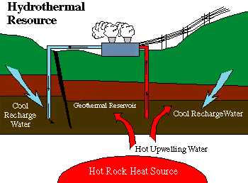

Figure3
For practical purposes these resources are sub divided into:
A] Vapor dominated systems (or) Dry steam fields:
In these systems the water is vaporized in to steam that reaches the surface in a relatively dry condition of about 200°C and rarely above 7kg/cm^3 or less. This steam is most suitable for generations of electrical power .The advantage of this system are more economical. But, the main problem with corrosive gases. These types of systems are very less; they are only five known sites in the world. The Geysers plant in the U.S., the largest one in the world, and Larderello in Italy, Motsukawa in Japan.
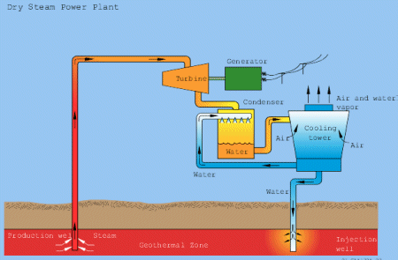
Figure4

Dry steam from the wells is collected,filtered to remove abrasive particles, which drive electric generators in the usual manner. The essential difference between this system and a conventinal steam turbine-generator system,using fossil or unclear fuel,is that geothermal steam is supplied at a much lower temperature and pressure.

B] Liquid dominate systems:
In these systems the hot water circulating and trapped under ground is at a temperature range of 175 °C to 315°C. When trapped by wells drilled in the right places and to the right depths, the water flows naturally to the surface or is pumped up to it. The drop is pressure, usually to 7kg/cm^2 or less, causes it to partially flash to a two –phase mixture of low quality i.e. liquid dominated. It consists relatively large concentration of dissolved solids ranging between 3000to25000ppm and some times higher. These solids effect power production because they precipitate and cause scaling in pipes and in the heat exchanger surfaces, thus reducing flow and heat transfer. Liquid dominated systems, however, are much more plentiful than vapor dominated systems. These are of two types
1.flashed system
2.Binary system
Liquid dominate systems: flashed system:
This is again divided in to two types.
a.] Single flashed system:
Flashed system is preferred for high temperature mixture of geothermal water, steam with low dissolved impurities. The mixture of water and steam are at more than at 180°C. this flash system is not suitable for temperature below 180°C and high dissolved impurities. In this system geothermal water, steam delivers to the flash system separator. The steam, water are separated and this steam is delivered to the turbine. This turbine is coupled to generator. The discharge from steam turbine is delivered to the direct contact condenser. The discharge fluid injected in. to the ground.

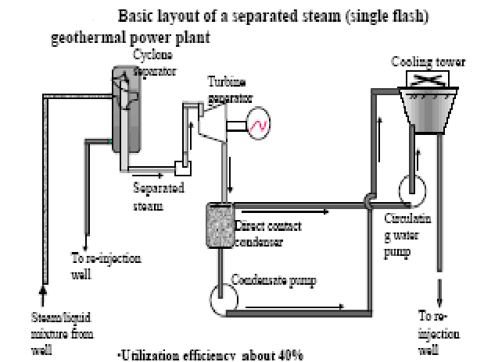 Figure5

Drawbacks:
1] This system requires much larger total mass flow rates through the well.
2] Due to the large amount of flow there is a greater degree of surface subsidence.
3] Greater corrosion of piping, well casing and other conduits.
4] Many times temperature and pressure of the water may not sufficient to produce flash steam.
b] Double flashed system:
Double flash system gives more power than single flash system under the same conditions. Depending upon the original water conditions the brine from flash separator is admitted to a second, low pressure separator where it flashes to a low pressure steam that would be admitted to a low pressure stage in the turbine.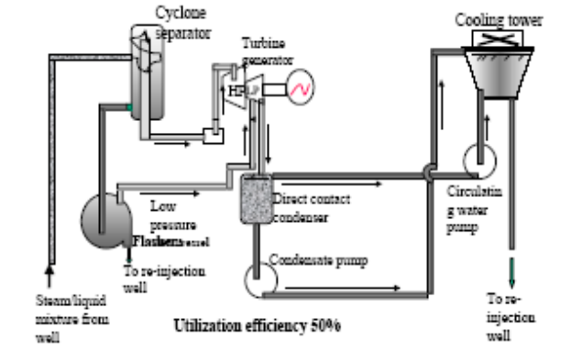 Figure6
It uses an innovative steam condenser and gas extraction system and a dual admission double flow steam turbine.
Liquid-dominated systems: Binary cycle:
In order to isolate the turbine from corrosive or erosive materials and to accommodate higher concentration of non-condensable gases, the binary cycle concept is now receiving considerable attention as an alternate power cycle concept. This is basically a Rankine cycle with an organic working fluid.
Hot water or brine from the under ground reservoir, either as un flashed liquid or as steam producing by flashing is circulated through a primary heat exchanger the hot brine transfer its heat to the organic fluid thus converting it to a superheated vapor that is used in a standard closed Rankine cycle. The vapor drives the turbine-generator .The exhaust vapor from the turbine is cooled in the regenerative heat exchanger and then condensed, using either and air cooled condenser or a water cooled condenser and cooling tower. The condensed liquid organic fluid is returned to the primary heat exchanger by way of the regenerative heat exchanger.
The hot geothermal fluid and the organic constitute the two fluids of the binary-fluid system. The condenser is cooled by water from a natural sour0ce, if available, or a cooling tower circulation system.
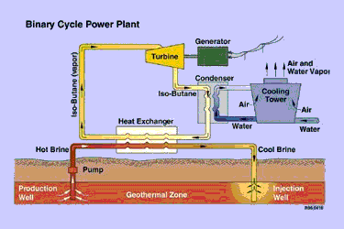
Figure7
If the temperature and salinity of the geo thermal brine are not high,the tendency of solids to deposit on surfaces in the heat exchanger is not to great.Where the temparature and salinity of the brine are high, this procedure may not be practicalbecause the heat exchangers may soon be rendered ineffective by scale deposition.
The first binary cycle was installed in the Soviet Union on the Kamchatka Peninsula in 1967 and its out put is 680kW.
2] Geopressure resources:
These resources occur in large deep sedimentary basins. The reservoirs contain moderately high temperature water (or) Brine under very high pressure. They are of special interest because substantial amounts of methane CH4 are dissolved in the pressurized water and are released when the pressure is reduced. Geopressured water is tapped in much deeper underground aquifers, at depths about 2400 to 9000m. This water is thought to be at the relatively low temperature of about 160°C and is under very high pressure, from the overlying formation above, of about 1050kg/cm^2. It has a relatively high salinity of 4% to 10 %. The geopressured resources are quite large. They could be used for the generation of electric power and the recovery of natural gas if suitable technology could be developed.
3] Hot dry rock resources:
These are very solid rocks occurring at moderate depths but to which water does not have access, either because of absence of ground water or the low permeability of the rock. In order to utilize this resource, means must be found for breaking up impermeable rock at depth, introducing cold water, and recovering the resulting hot water for use at the surface. The known temperatures of HDR vary between 150°C to290°C. This energy is called petrothermal energy. There are two methods to tap this energy:
- High-pressure water
- Nuclear explosives.
Efforts going to tap this energy in a best economic way.
4] Magma resources:
These consist of partially or completely molten rock, with temperatures in excess of 650°C, which may be encountered at moderate depths, especially in recently active volcanic regions. These have large geothermal energy content, but restricted to some places and this high temperature will make difficulty to extract.

Advantages:

1)Geothermal energy is versatile in it use
2)It is cheaper, compared to the other energy sources.
3)It deliverse greater amount of net energy from its system then other alternative or conventional systems
4) Once you've built a geothermal power station, the energy is almost free
5) The power stations do not take up much room
6) Geothermal energy power plants has highest annual load factors of 85%to90% compared 45% to 50% of for fossil fuel plants.
7) Least polluting compared to other conventional resources.

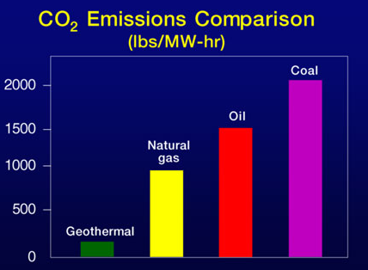 Figure8

Disadvantages:

1.The cost to the environment:
Geothermal power is considered a nonpolluting source of energy, but it does have some serious environmental drawbacks. . Roads must be built to the sites, which are usually remote because the land around geothermal vents is usually too unstable for human habitation. Wells must often be dug, which disrupts the natural flow of groundwater. The steam used at geothermal plants can also become a source of air pollution if it is released into the atmosphere. Frequently it is heavily laced with salts and sulfur compounds that are leached from the earth's crust. If the steam is simply condensed and released into the natural waterways, the high levels of salts and sulfurs can be toxic to aquatic wildlife.
2.Overall efficiency is low (15%) as compared to fossil fuels (35-40%).
3.Drilling operation is noisy.
4. Although. Geothermal vents are found throughout the world, they are only in large enough numbers to make geothermal power viable in few select areas. The United States has several sites in California and Hawaii. New Zealand, Iceland, and the islands of Indonesia are also rich in geothermal power is not available for a large number of nations sites.
5.Most forms of geothermal energy are not truly renewable resources.

Applications:

1.Direct use:
a] Aquaculture:
The cultivation of fish and other aquatic creatures, and plants using geothermal water is big business in Idaho. Catfish, tilapia, ornamental fish, coral reefs, and alligators are all being raised in Idaho thanks to geothermal water, which is perfectly suited to these life forms.
b] Greenhouses:

Geothermal water has been used for greenhouse operations in Idaho since the 1930's when Thomas Edwards began using the resources to grow plants in northwest Boise. There are currently 10 greenhouse operations across southern Idaho that use geothermal water to grow a variety of vegetation

c] Heating:

Geothermal water is used to heat homes and buildings in several areas of the state. Idaho's State Capital building and many other public and private buildings along the Boise Front are exothermally heated

d] Recreation:

In Idaho, about 200 geothermal springs with surface water temperatures that range from 86 - 199° F. Some type of significant development, such as swimming pools, soaking pools, hot tubs, indoors baths, etc. has occurred at 34 of these geothermal locations. At many other remote geothermal hot springs in Idaho (the majority being in mountainous settings), minor changes have been made, such as arrangements of rocks and timbers, in order to form small pools for soakers

2.Geothermalheatpumps:
The relatively constant temperature of the top 15 meters of the Earth's surface (or ground water) can be used to heat or cool buildings indirectly. The pump uses a series of pipes to circulate fluid through the warm ground. In the winter when the ground is warmer than the buildings above, the liquid absorbs heat from the ground, which is then concentrated and transferred to the buildings. This can also be used to heat domestic water. In the summer, when the ground is cooler, the pump transfers heat from the buildings back into the ground.

3.electricityproduction:
There are three types of power plant that can convert geothermal energy to electricity, depending on the temperature of the geothermal fluid used. All three use a turbine that is driven by steam, which then drives a generator to produce electricity.
We can clearly observe how the process takes place from the below figure. Well bore, well site, satellite station, plant station, injection well, power plant, transmission are different stages involved in electricity production.
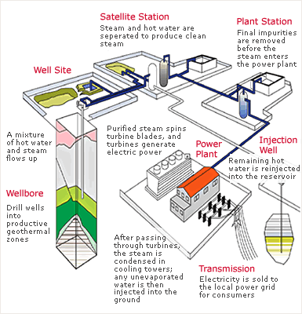
Figure9

Geothermal occurrence in India:

1.N.W.Himalayan geothermal province.
2.North India Precambrian province
3.Cambay Graben province.
4.East Indian Archaean province.
5.Naga-Lushai geothermal province.
6.Damodar valley Graben province
7.Mahanandi valley Graben province
8.Narbada Tapti Graben province
9.Godavary valley Graben province
10.Andaman Nicobar Geothermal province. Etc.

Potential of geothermal resources in India:

There are about 340 known thermal areas in India, each represented by hot or warm springs. Many more areas being discovered and reported, in the 12 well-defined geothermal provinces. The total stored heat potential of the 93 systems considered is 36.87X10^18 calories, which is equivalent to the combustion energy of 5160 million tones of coal (or) 25440million barrels of oil.38 of these systems are of high temperature type whose heat energy could be considered for electrical power generation. Their estimated cumulative potential for power generation is of the order of about 500MW for 100 years.
But In India only one pilot plant is in operation in puga valley, in Jammu and Kashmir, having 20MW capacity. Another plant is at Parvati Valley, Himachal Pradesh is under construction. A 7.5 tones capacity cold storage pilot plant based on geothermal energy was installed at Manikaran, Himachal Pradesh. A 5kW pilot power plant is under fabrication at the National Aeronautical laboratory; bang lore.

Future:

The short to medium term future of geothermal energy is encouraging, providing some hurdles that have recently slowed its growth are overcome. Energy prices have increased significantly since the second half of 1999. Plans already drafted at the end of the 1990’s, but partly delayed, by Indonesia, Philippines and Mexico aim at an additional 2 000 MW before 2010. In the direct use sector, China has the most ambitious target: substitution of 13 million tons of polluting coal by geothermal energy
Improved use of hydrothermal resources, limitation of front-end costs and increased ground heat extraction are the keys to a steady development of conventional geothermal energy. Installation of a large number of binary power plants will increase electricity production from wide geographical areas underlain by medium-temperature resources: a good example is the Altheim plant just inaugurated in Austria, which has added power production to district heating with 106ºC water. Heat readily available in earth can be optimized by adding compatible uses. New horizons for geothermal energy can be opened up with fresh applications, for example drinking water production on islands and in coastal areas with scarce resources (e.g. the project starting in 2001 on Milos, Greece). Finally, GHP systems can be replicated in many parts of the world.
The long-range future of geothermal energy depends on HDR systems becoming a technological and economic reality. It has been estimated that the heat resources located at economically accessible depths could support, in North America and Europe, an amount of power generation capacity by HDR systems of the same order or greater than present nuclear capacity.
Currently there are about twenty countries that harness the power of geothermal energy. The United States produces about 45 percent of all geothermal power in the world. Some scientists believe these numbers will increase, as they think the potential for geothermal power has not even begun to be explored. Simply using today's technology and applying it to all available geothermal sites would increase the output of electricity from about 8,240 megawatts to 70,000 megawatts. Using technologies that are being currently researched could increase this figure to as much as 138,000 megawatts. This would be enough power to continuously satisfy about 8 percent of all the energy needs in the world.
Scientists are also investigating better drilling techniques. It is hoped that they will discover a way to drill into the crust of the earth in the ocean without disturbing the natural cycles of the water. Oceanic crust was selected for these studies because this is where the crust of the earth is the thinnest—sometimes as little as ten miles thick—but still thick enough for drilling. If this investigation is successful, geothermal energy will become an unlimited supply of power for human use. No longer will humans have to rely on natural geothermal features to be able to build geothermal plants. Geothermal power will be able to power human needs for electricity for as long as the mantle of the earth remains hot, which scientists believe will be for hundreds of millions of years more.

References:

[1] H.Christopher, H.Armstead, “Geothermal energy”, a Halsted press book, New York, 1978.

[2] “Santa Rosa/Geyser Pipeline Update”, Geothermal Resources Council Bulletin, GRC (1999), Vol. 28 (5), Davis, CA.

[3] “Reconstruction of a Pavement Geothermal Deicing System,” Geo-Heat Center Quarterly
Bulletin, Lund, J. W. (1999), Vol. 20, No. 1 (March), Klamath Falls.

[4] “Aquaculture in the Imperial Valley - A Geothermal Success Story,” Geo-Heat Center Quarterly Bulletin, Rafferty. K. (1999) Vol. 20 (1), Klamath Falls.

[5] Rakosh Das Begamudre, “energy conversion systems”, New Age International Publishers, New Delhi, 2000.

[6] S.Hasan saeed, D. K. Sharma, “Non-Conventional energy resources”, Katson publications, New Delhi, 2006-07.

[7] G.D.Rai, “Non-Conventional energy sources”, Kanna publications, New Delhi, 2006.

[8] Rybach, L., Megel, T., Eugster, W.J., “How Renewable are Geothermal Resources?” Geothermal Resources Council Transactions, Vol. 23, October 1999.

[9] EPRI, “Renewable Energy Technology
Characterizations”, DOE Report TR-109496, December
1997.

[10] Boyd, T. L. (1999), “The Oregon Institute of Technology Geothermal Heating System - Then and Now,” Geo-Heat Center Quarterly Bulletin, Vol. 20, No. 1 (March), Klamath Falls.

[11] www.geothermal.marin.org

[12] www.geos.iitb.ac.in

[13] www.crest.org

